RAJALAKSHMI ENGINEERING COLLEGE
Name :
Year / Branch / Section : University Register No. :
..
College Roll No. :
.
Semester :
.
Academic Year :
.
RAJALAKSHMI NAGAR, THANDALAM- 602105.



CS23333 OOPS Using Java
Laboratory Record Note Book


RAJALAKSHMI ENGINEERING COLLEGE

An Autonomous Institution

BONAFIDE CERTIFICATE

Name: ……………………………………………………………………………

Academic Year: …………… Semester: …………… Branch: …………

Register No.

Certified that this is the bonafide record of work done by the above student in the. Laboratory
during the academic year 2025- 2026

Signature of Faculty in-charge

Submitted for the Practical Examination held on……………………………

Internal Examiner External Examiner

EX.NO | DATE | NAME OF THE EXPERIMENT | GITHUB QR
1 |  | I/O, Data Types, Operators
2 |  | Control Structures
3 |  | Arrays
4 |  | Strings
5 |  | Classes & Objects
6 |  | Inheritance
7 |  | Interface
8 |  | Exceptions
9 |  | Collections
10 |  | Collections
11 |  | Project
12 |  | Lambda
INDEX

ABSTRACT

The Lost and Found Management System is a Database Management System (DBMS) project developed to maintain systematic records of lost and found items within an organization or institution. The main objective of this project is to design and implement a reliable database-driven solution that helps users report lost items and register found items efficiently. The system uses MySQL as the backend to store and manage data such as item details, user information, location, and status, while the Java-based frontend provides an interactive interface for users and administrators. Through effective database design and normalization, the system ensures data consistency, integrity, and security. The administrator can perform operations such as inserting, updating, deleting, and retrieving item records using SQL queries. This DBMS project eliminates manual record-keeping, minimizes data redundancy, and enables faster searching and matching of lost and found items. Overall, the project demonstrates the practical application of database concepts in solving real-world problems through efficient data management and retrieval.

TABLE OF CONTENTS

CHAPTER NO. TITLE PAGE NO
ABSTRACT iv

1 INTRODUCTION 1
1.1 INTRODUCTION 8
1.2 SCOPE OF THE WORK 8
1.3 PROBLEM STATEMENT 8
1.4 AIM AND OBJECTIVES OF THE PROJECT 8
2 SYSTEM SPECIFICATIONS 9
2.1 HARDWARE SPECIFICATIONS 9
2.2 SOFTWARE SPECIFICATIONS 9
3 MODULE DESCRIPTION 10
4 CODING 11
5 SCREENSHOTS 16
6 CONCLUSION AND FUTURE ENHANCEMENT 18
REFERENCES 19

LIST of figures
FIGURE NO. | TITLE | PAGE NO.
5.1 | INTRODUCTION PAGE | 15
5.2 | CUSTOMER DETAILS | 15
5.3 | BOOKING LOG | 16
5.4 | BOOKING CREATION | 16
5.5 | DELETION OF BOOKING | 17
5.6 | DATABASE CREATION | 17

CHAPTER 1
INTRODUCTION
  - INTRODUCTION
The Lost and Found Management System is a database-based project designed to record and manage lost and found items efficiently. It helps users register lost belongings and report found items through an organized digital platform. Using Java as the frontend and MySQL as the backend, the system ensures secure storage, easy retrieval, and effective data management.
  - SCOPE OF THE WORK
The system provides a centralized database to store and manage all lost and found item records efficiently. It allows users and administrators to easily search, update, and track item details. The project can be implemented in institutions, offices, or public places to simplify the management of lost belongings.
  - PROBLEM STATEMENT
Managing lost and found items manually often leads to data loss, duplication, and difficulty in tracking items. There is no efficient way to match lost items with found ones quickly. Hence, a database-driven system is needed to store, manage, and retrieve records accurately and efficiently.
  - AIM AND OBJECTIVES OF THE PROJECT
The main objective of this project is to allocate the available taxis according to the customer requirement. This system helps to maintain the availability and details of taxis in a local transportation agency. This will allow the agency to beat the competition from rival agencies by providing efficient service.

CHAPTER 2
SYSTEM SPECIFICATIONS
2.1 HARDWARE SPECIFICATIONS
Processor | : | Intel i5
Memory Size | : | 8GB (Minimum)
HDD | : | 1 TB (Minimum)

2.2 SOFTWARE SPECIFICATIONS
Operating System | : | WINDOWS 10
Front – End | : | Java
Back - End | : | MySql
Language | : | Java, MySQL

CHAPTER 3
MODULE DESCRIPTION
This application consists of two modules. When the program runs, it will ask for a confirmation to the login window. The person who interacts can login as an Administrator or as a User. The description of the modules are as follows:
- Admin login
When the person who interacts tries to login as Admin then he needs to login with his username and password. The administrator only has the power to change and manipulate the data in the database.
2. User login
When the person tries to login as a user then he/she will be prompted to enter
the number of symptoms and the final result will be printed in the form of
table.

CHAPTER 4
SAMPLE CODING
import java.sql.*;
public class DBConnection {
private static final String DB_NAME = "lost_found_db";
private static final String URL_NO_DB = "jdbc:mysql://localhost:3306/?useSSL=false&allowPublicKeyRetrieval=true&serverTimezone=UTC";
private static final String URL_WITH_DB = "jdbc:mysql://localhost:3306/" + DB_NAME + "?useSSL=false&allowPublicKeyRetrieval=true&serverTimezone=UTC";
private static final String USER = "root";
private static final String PASSWORD = "Tommybella@9125";

public static Connection getConnection() {
try {
Class.forName("com.mysql.cj.jdbc.Driver");
try {
return DriverManager.getConnection(URL_WITH_DB, USER, PASSWORD);
} catch (SQLException ex) {
if (ex.getMessage().toLowerCase().contains("unknown database")) {
try (Connection conn = DriverManager.getConnection(URL_NO_DB, USER, PASSWORD);
Statement stmt = conn.createStatement()) {
stmt.executeUpdate("CREATE DATABASE IF NOT EXISTS " + DB_NAME + " CHARACTER SET utf8mb4 COLLATE utf8mb4_unicode_ci");
}

return DriverManager.getConnection(URL_WITH_DB, USER, PASSWORD);
} else {
throw ex;
}
}
} catch (ClassNotFoundException e) {
System.out.println("MySQL JDBC Driver not on classpath");
e.printStackTrace();
} catch (SQLException e) {
System.out.println("Database connection failed: " + e.getMessage());
e.printStackTrace();
}
return null;
}
}

CHAPTER 5
SCREEN SHOTS
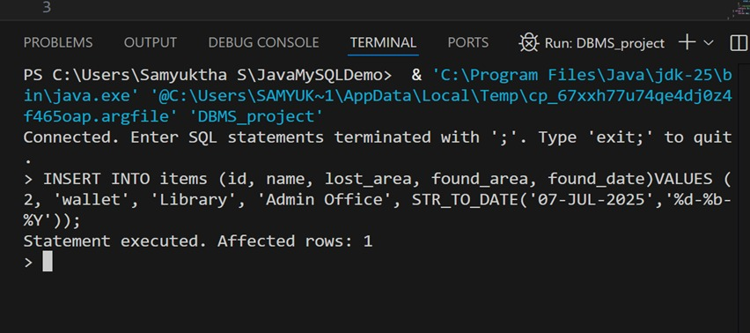
Fig1. SQL connection in java
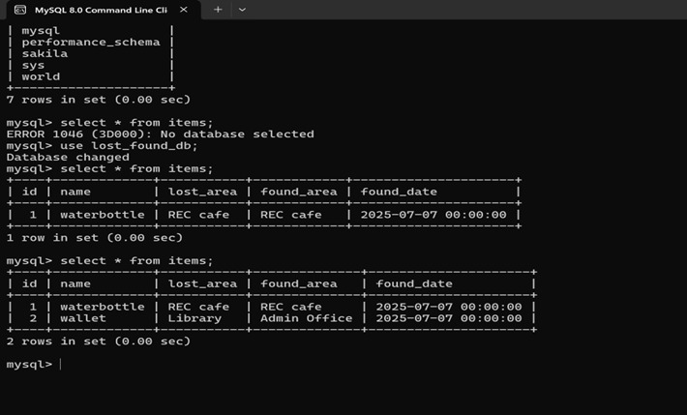
Fig2. Output in MySQL
CHAPTER 6
CONCLUSION AND FUTURE ENHANCEMENT
The Lost and Found Management System successfully provides an efficient and organized way to record, manage, and retrieve lost and found items using a database-driven approach. By integrating Java for the frontend and MySQL for the backend, the system ensures smooth data handling, reliability, and ease of use. It eliminates the challenges of manual record-keeping and reduces the time required to locate items. Overall, the project demonstrates how database concepts can be effectively applied to solve real-life problems.
In the future, the system can be enhanced by adding features like image upload for items, email or SMS notifications, user authentication, and cloud-based data storage. A mobile application version can also be developed to make the system more accessible and user-friendly. These improvements would further increase the system’s efficiency and usefulness in large organizations or public environments.

REFERENCES
- https://www.w3schools.com/sql/
- https://www.tutorialspoint.com/sqlite/index.htm
- https://www.wikipedia.org/
- ChatGPT

